 

**Placement Empowerment Program**

***Cloud Computing and DevOps Centre***

**Set up a load balancer in the cloud :** Configure a load balancer in your cloud to distribute traffic across multiple VMs hosting your web application.

Name: Subiksha R Department: AML



**Introduction**

Azure Load Balancer is a highly available, scalable load balancing service that distributes incoming traffic to multiple virtual machines (VMs) hosting web applications. It helps ensure that web applications remain available and responsive even during periods of high traffic. The load balancer can also monitor the health of the VMs and only route traffic to those that are healthy, improving the overall performance and reliability of the application.

In this task, we will configure an Azure Load Balancer to distribute HTTP traffic across multiple VMs, ensuring that the web application is highly available and scalable.

### ****Overview****

Azure Load Balancer helps manage traffic by directing it to multiple VMs behind the load balancer. It ensures that the VMs hosting the application are evenly utilized and that users experience consistent performance regardless of which VM their request is routed to.

This guide involves:

1. Setting up a public load balancer.
2. Configuring a backend pool to hold the VMs.
3. Creating a health probe to monitor the health of the VMs.
4. Adding load balancing rules that dictate how the traffic should be distributed.
5. Ensuring proper network security to allow traffic from the load balancer.

**Objectives**

The primary objective of this task is to set up an Azure Load Balancer to:

1. Distribute incoming HTTP traffic across multiple virtual machines.
2. Ensure high availability and fault tolerance of the web application.
3. Configure health probes to monitor the health of the VMs.
4. Create load balancing rules that route traffic to healthy VMs.

**Step-by-Step Overview**

**STEP 1 : Sign In and Select/Create a Resource Group**

* Sign in to the [Azure Portal](https://portal.azure.com).
* Create or select an existing resource group in the same region as your VMs

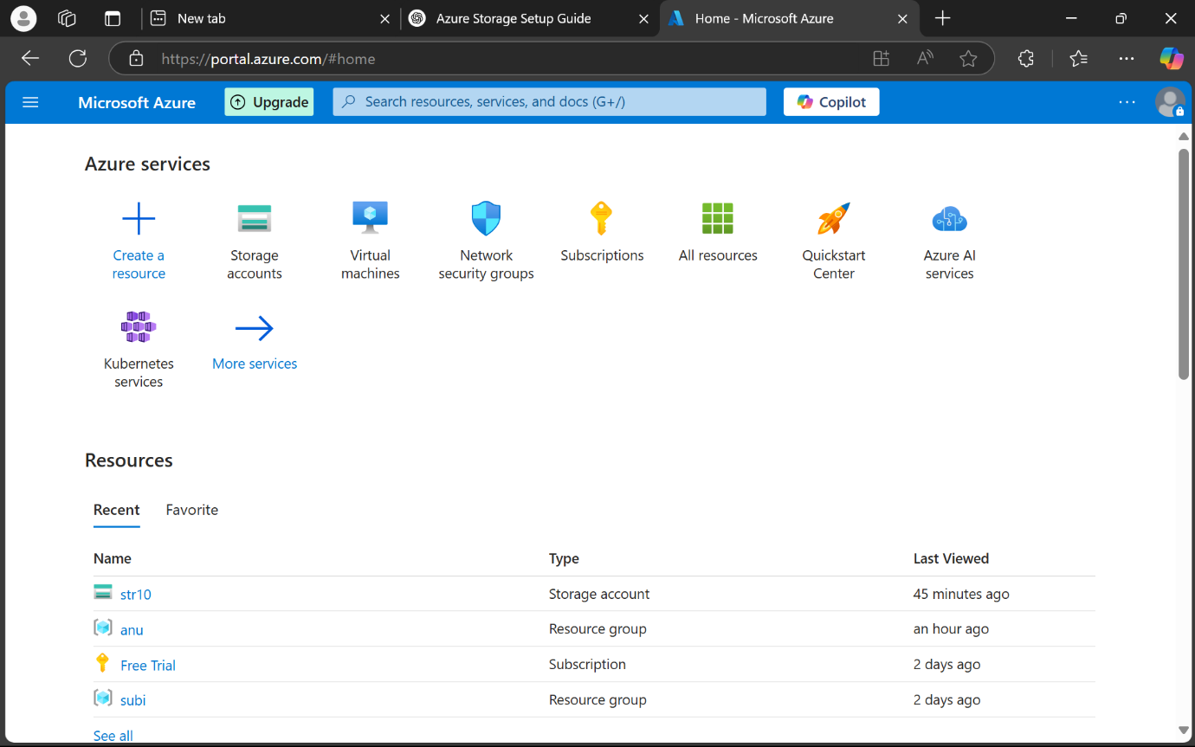

**STEP 2 : Create a Public Load Balancer**

* Search for **Load Balancer** in the Azure Portal.
* Click **Create**, and fill in the required information such as subscription, resource group, region, and name.

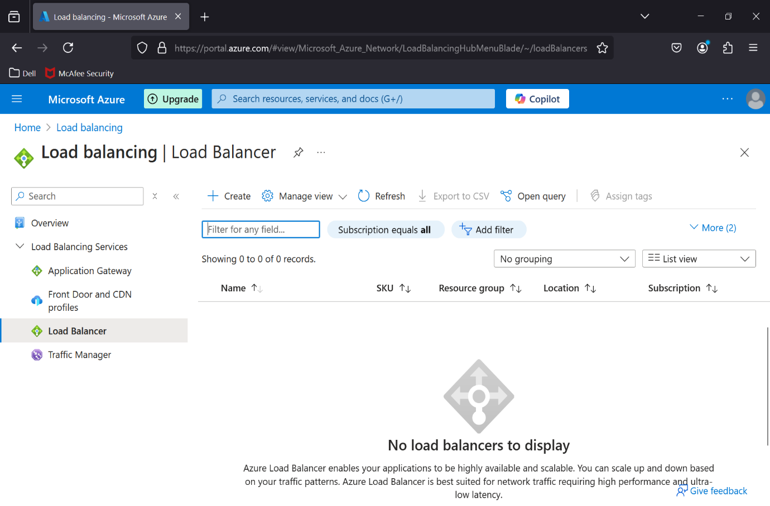

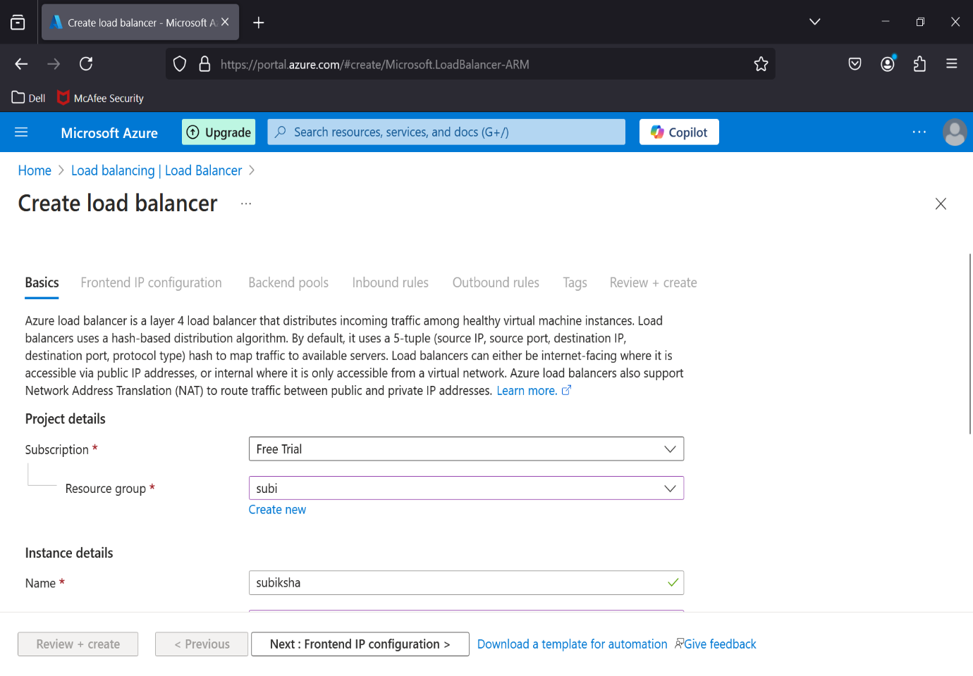

**STEP 3 :** Create a new public IP address for the load balancer.

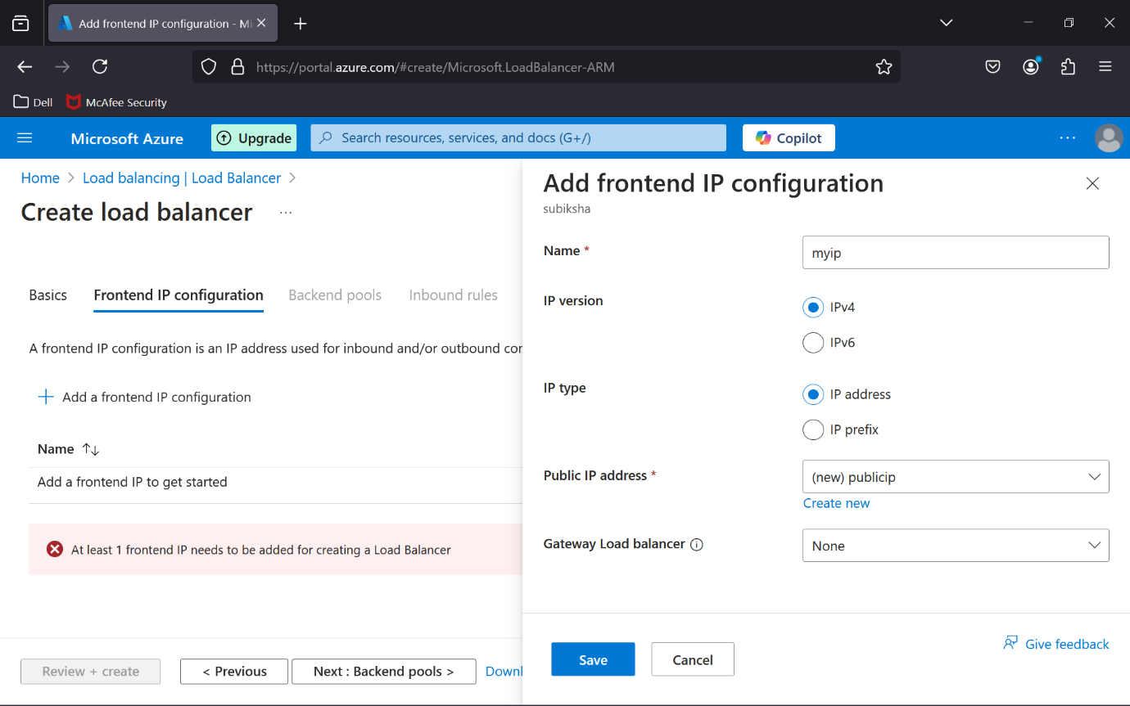

**STEP 4 : Configure the Backend Pool**

* Navigate to the Backend pools section of the load balancer.
* Add a backend pool and select the VMs you want to include

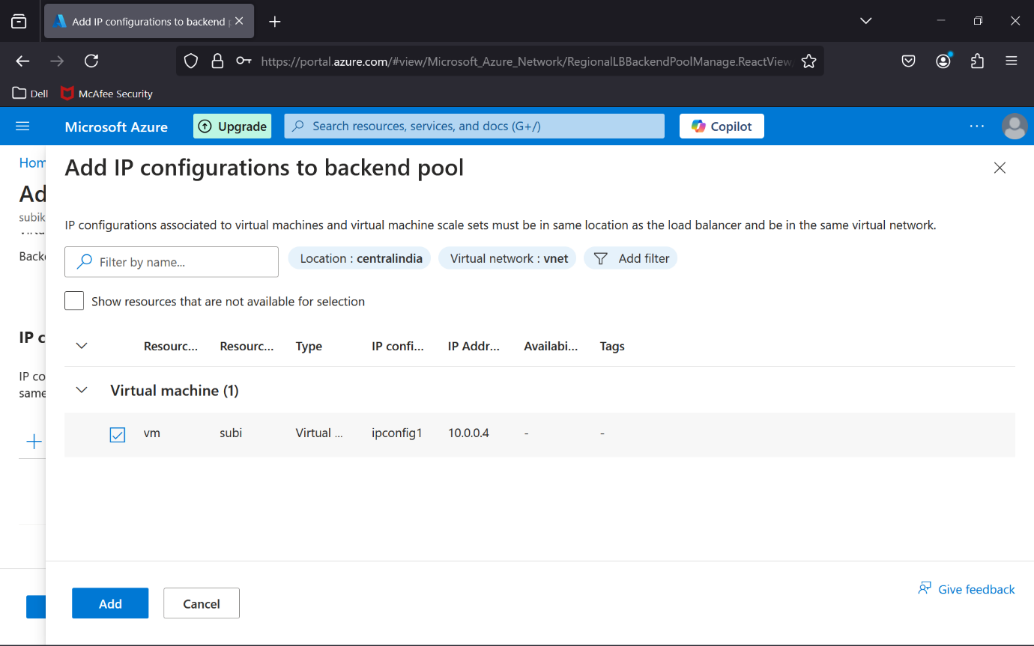

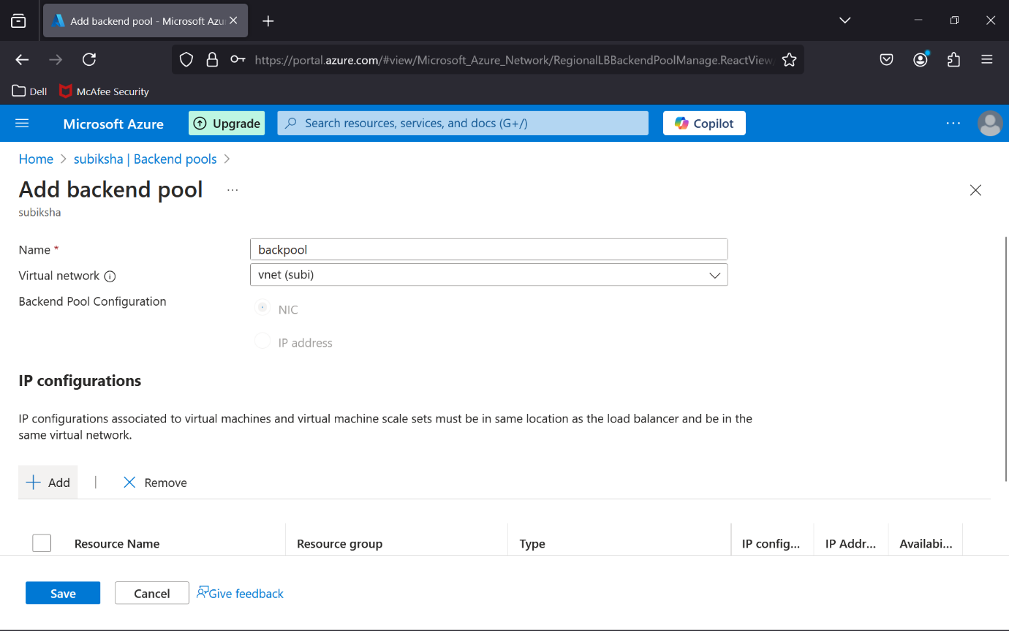

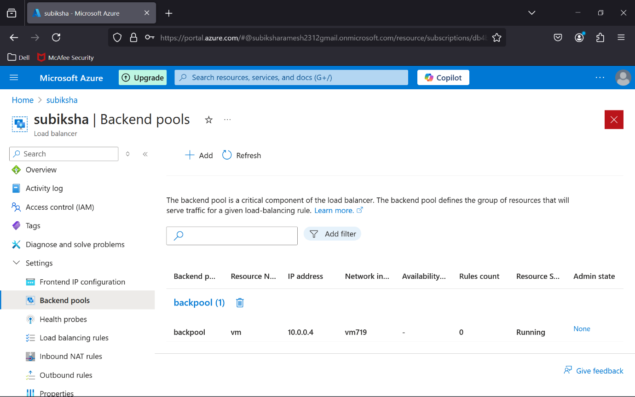

**STEP 5 : Create a Health Probe**

* In the load balancer’s menu, go to Health probes.
* Add a health probe to monitor the health of the VMs (typically using HTTP on port 80).

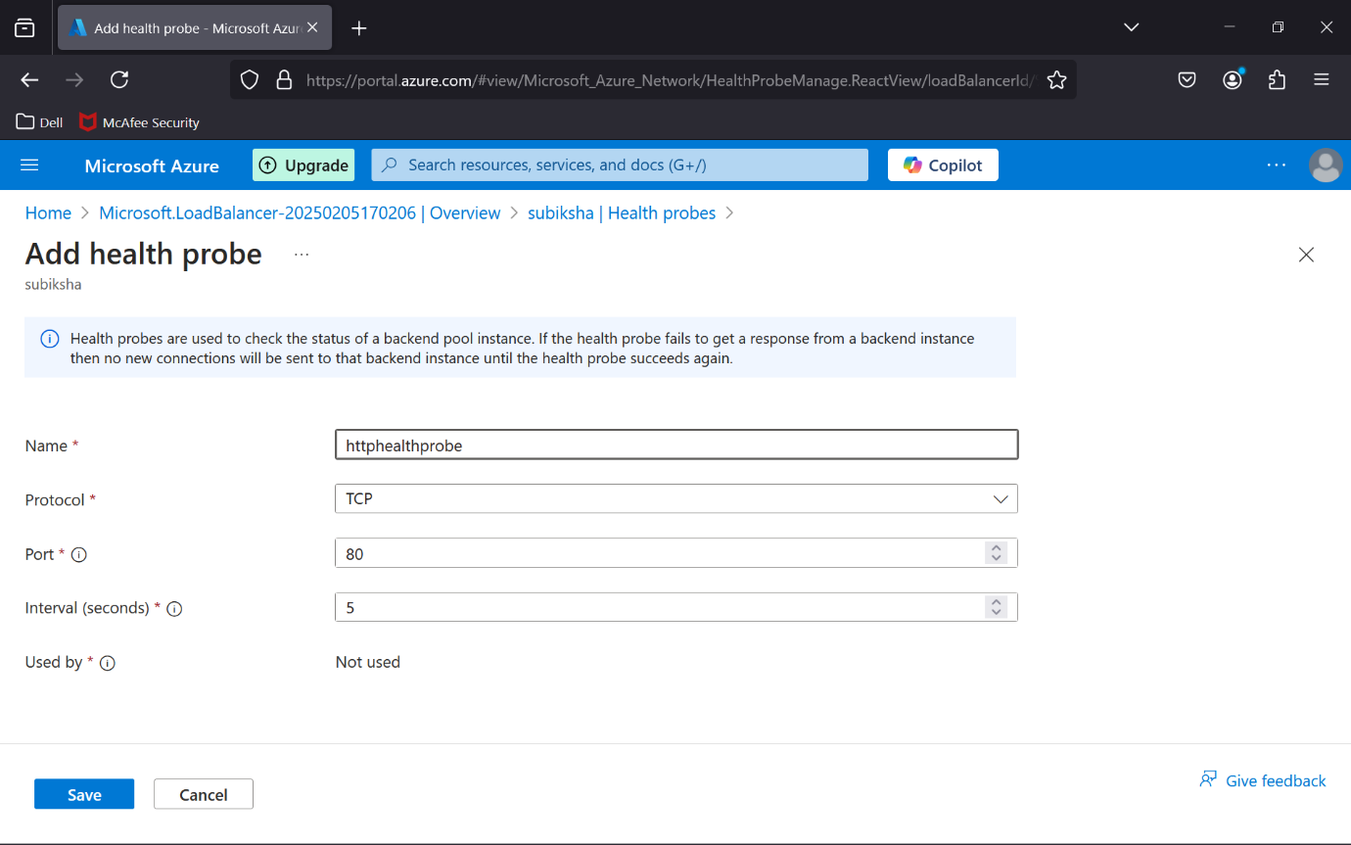

**STEP 6: Test Your Load Balancer**

1. Use the public IP address of the load balancer to test if the traffic is properly distributed across the VMs.
2. Monitor traffic distribution using Azure monitoring tools.

**Outcome :**

By following this procedure, you will have successfully set up an Azure Load Balancer that:

1. Distributes incoming traffic across multiple VMs.
2. Ensures high availability and fault tolerance of the web application.
3. Monitors VM health using health probes, ensuring that only healthy VMs receive traffic.
4. Provides scalability for your web application to handle higher traffic loads.

The outcome will be a highly available and scalable web application with Azure Load Balancer managing and distributing traffic efficiently across VMs.